HIPs with a Purpose -

©Suhas Aggarwal (suhas@iitg.ernet.in)

TIME BASED CAPTCHA -

Main idea behind this CAPTCHA is to make use of challenges which humans can solve quickly but computers take some time to solve.
These CAPTCHAs expire ,if they don’t receive a response in a particular time interval.

1)
Splash random alphabets on random positions on a screen at different time instants.
Alphabets will appear for an instance and then disappear.
User will have to type alphabets in a sequence they appeared.
2)
Display simple images in a sequence.
Images will appear for an instance and then disappear.
User will have to describe images in a sequence they appeared.
Sample images are such as those labelled by an ESP game.

PURPOSE :

Measuring reaction times of human beings.
A good data about human beings which is otherwise difficult to obtain and is very useful.

SENTENCE BASED CAPTCHA -

A sentence is selected. We pick up two random words and degrade them by
crippling their text (GIMPY) for interfaces with GUI support or by using Text - Graphics character based CAPTCHAs for interfaces with text support only such as SSH accounts.
Two random words are selected from the sentence again and are swapped.A Random alphabet is filled in each whitespace present in the sentence.
Challenge is to guess the sentence and write the sentence in correct format by
inserting whitespaces between words.
A possible reversible attack ,which I have currently thought of , is to write a program which can guess correct words in the sentence and perform
a search over the web and identify the correct sentence from the results obtained.
A new degrading scheme which can be useful in this scenario is to omit out certain alphabets from the words and present a sentence composed of partially ‘eaten up’ words.

PURPOSE :

Educating people.
Sentence can be general knowledge facts ,thoughts of the day,recent headlines.
(Imagine how cool! will it be, if one can catch up with the latest news while just checking regular emails!)

HUMAN EMOTION BASED CAPTCHA -

A statement or a graphic is displayed to the user arousing human emotion.
User has to choose an emoticon , describing his feeling as an answer .

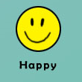

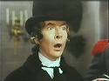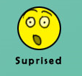

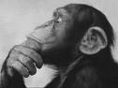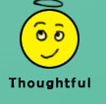

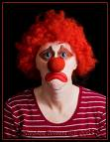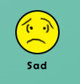

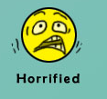

Not all scars show, not all wounds heal
Sometimes you can't always see
The pain someone feel
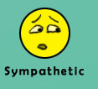

Are children who act in rated 'R' movies allowed to see them?

"The internet is a great way to get on the net."
- Bob Dole, Republican presidential candidate

The man who smiles when things go wrong has thought of someone to blame it on.
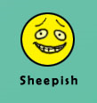

Hewlett Packard’s first product was an automatic urinal flusher


In the late '90s, Microsoft secretly developed its own version of Linux, but shelved it after quality control researchers deemed it "too stable".
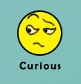

PURPOSE -

Can be indirectly used for conducting online polls on a very large scale!

A sample –

Austrian-born actor Arnold Schwarzenegger has won the race to become governor of California, pledging to become a "governor of the people."

 - 35%

 - 35%

 - 30%

SCENARIO BASED CAPTCHA –

Most of the Captchas employed today are based on the difficulty of image recognition, such as identifying degraded words etc .With the advancement in field of computer vision these Captchas have already been broken.
Idea behind this CAPTCHA is to utilize the analytic and understanding capability of humans rather than merely recognizing objects. A scenario is presented to the user. Here are few figures depicting a scenario.

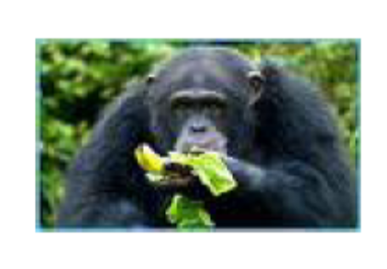
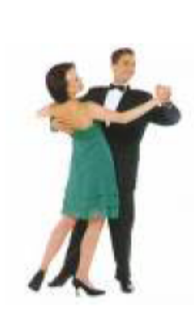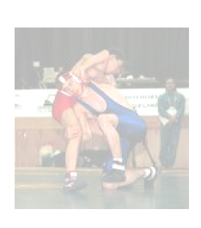

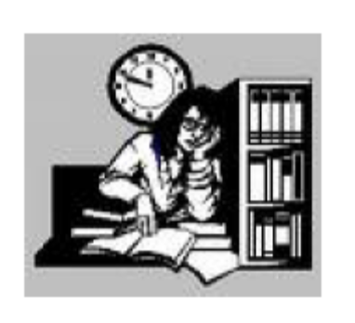

These figure illustrates various scenarios such a monkey eating a banana , a couple dancing, a student studying at night, two people wrestling.
A graphic like this is presented to the user.
He has to type in the expression depicting a scenario. Answer is a simple expression
such as those described above.
There can be multiple answers possible as well such as a chimp eating, a couple performing a ballroom dance ,a student studying for his exam etc. These expressions
are simply paraphrases and can be easily tackled due to advancements in computational linguistics today.Paraphrase recognition systems such as iSTART can be used for recognizing paraphrases.
This Captcha uses a step higher than object recognition that is identifying the objects present in the picture as well as how they are related.
By using object recognition techniques we can analyse various objects present in the images but identifying relationship among them is a hard AI problem to crack .
Moreover they may be related in multiple ways and unique relationship can only be identified from image shown.
Distortions such as blurring images can also be added to make it complex for computers to tackle.

Current work involves designing experiments and implementing prototypes related to these CAPTCHAs .

